Steven Kim  
(Partner: Hoi Leung)  
Mr. Mason  
Adv Cisco CCNP P1,2  
10/29/13

**Lab 4 – LSA Types and Stub Networks**

**Part 1: Identifying Different Types of LSAs**

In an OSPF network, a type of communication called LSA, or Link State Advertisement, is distributed throughout the router’s local topology, within the same area. OSPF is a link-state routing protocol that allows communication between devices within the same autonomous system. In this LSA is a link-state ID which There are 11 types of LSA and 4 main types of OSPF Stub networks:

Type 1 LSA: Also known as the Router LSA, this type of LSA is flooded across a routers or networks in the same area with the same metrics. The link-state ID is the router-id of the router sending out LSA 1.

Type 2 LSA: This LSA is also known as the network LSA and is flooded across the same area in which the originating router is in. The DR, or Designated Router, announces which routers are adjacent to the broadcast segment. The link-state ID is the IP interface of the DR.

Type 3 LSA: For this type of LSA, an Area Board Router, ABR, sends out a summary of the information it collected and removes detailed topology information in the process. The link-state ID is the network number of the destination that the LSA is going to.

Type 4 LSA: Also known as the ASBR Summary LSA, this LSA presents next-hop information that Type 5 LSAs do not. An ABR, or Area Border Router, sends information to the origin of the Type 5 LSA that was sent out. The link-state ID is the router-id of the ASBR (for type 4 LSAs).

Type 5 LSA: Also known as the External LSA, this LSA floods information from other routing processes into OSPF. An external metric is shown in the routing table. Usually, this type of LSA does not show up in Stubby or Not-So-Stubby networks.

Type 6 LSA: Also known as the Group Membership LSA, this LSA supports Multicast extensions to MOSPF, or Multicast OSPF. This LSA is obsolete since OSPF v3 has replaced MOSPF. Only a few Routers are able to support this type of LSA.

Type 7 LSA: This type of LSA is responsible for sending external routing information to ABRs. Typically, these LSAs are only sent out in NSSA, since in NSSA networks, only information regarding redistribution of external routes is permitted to be sent throughout the network. Therefore, Type 7 LSAs are translated into Type 5 LSAs when flooded into the rest of the OSPF network.

Type 8 LSA: This LSA is a link-local for OSPFv3. It provides a list of IPv6 addresses as well as information about link-local addresses.

Type 9 LSA: This LSA is a link-local "opaque" LSA in OSPFv2 and an Intra-Area-Prefix LSA in OSPFv3. In the link-state ID of the latter are prefixes for stub networks.

Type 10 LSA: This LSA is a link local “opaque” LSA that contains information flooded by other Routers. It floods additional information like link bandwidth and color which are beyond its metric.

Type 11 LSA: This type of LSA is flooded to all non-stubby areas. It is also known as an "opaque" LSA, which type is the same as a Type 5 external LSA.

As "opaque LSAs," Types 9, 10, and 11 LSAs flood information about bandwidth and link color.

All LSAs have 20-byte headers, and one of them consist of the link-state ID.

**Part 2: Configuring different Stub Areas and identifying the different types of LSAs present in them.**

**Purpose**

The purpose of this lab was to identify different types of LSAs that are present in each Stub area, to learn how to configure different Stub networks, and to verify that such networks have been established.  
**Background Information on Lab Concepts**

Stub networks: Networks that send most of its traffic through a single path, that path often being the default-route to other networks.

Regular Area: A non-stubby area in which types 1, 2, 3, and 5 LSAs are present; such LSA types are present since there are no restrictions of being a Stubby area.

Stubby Area: An area that receives traffic from other areas except from external routes in which a default route is noted. This area will have types 1, 2, and 3 LSAs.

Totally Stubby Area: A Stubby area that has a default route to connect to the rest of the networks. This area will have types 1, 2, and 3 LSAs; however, there is only one type 3 LSA since there is a summary route (not configured manually, but automatically) to the backbone area.

Not-So-Stubby Area: A stubby area that can forward external routes. This area converts type 7 LSAs into type 5 LSAs and will send them to the backbone area. This area does not have type 3 LSAs since it is not summarizing its routes for the rest of the network. However, it has types 1 and 2 LSAs.

**Lab Summary**

To know what kinds of LSAs are present in different stub areas, I created a topology consisting of seven Routers and four Switches. Four of routers each made separate areas in which LSAs went through. Another Router was connected to the NSSA Network to test if Type 7 LSAs were being sent out properly when the area has an external route. Each of the areas represented a stubby network, a totally stubby network, a not-so-stubby network, and a regular OSPF (not stubby) network. There were also two border routers in this topology that were incorporated in the backbone area (area 0).  
 Initially, I configured IP addresses of all devices. I then set up OSPF on Six different routers for connectivity. Finally, I set up RIP on Router 7 in order to receive Type 7 LSAs.  
 Since OSPF and RIP are different routing protocols, I had to redistribute routes from both networks to each other to ensure connectivity throughout the entire topology.   
 After the initial set up was completed, I configured each area with commands necessary for establishing its type of area. Each area had its unique command that distinguished each other. I also had to configure border routers so that the network is aware of the stub networks that were configured on the four individual Routers (see commands in Lab Commands).  
 I verified that the network had full connectivity by pinging from one host to another issuing the command *Router (config)# show ip route* on all routers. I realized that a router marked N2 was present in the border router connecting the nssa area to the rest of the network was present, to denote the presence of an external router in the nssa area. The hosts were able to successfully ping each other.  
 Finally, I had to check different kinds of LSAs in different networks using Wireshark. However, I did not receive any LSAs initially when I started my capture. After going through the hassle of researching, I discovered that the interfaces connecting to the ABRs had to be shut down and then turned back on by issuing the command no shutdown.   
 By connecting to each of the areas, I realized that Stubby areas and Standard (Regular) areas had Type 1, 2, 3, and 5 LSAs. Totally Stubby areas had Types 1, 2, 3 LSAs, but there was only 1 Type 3 LSA that represented a default route to the network (the default route was not configured; it was automatically there). The NSSA area did not have type 3 LSAs; instead, they had type 7 LSAs that showed that NSSA has RIP and OSPF concurrently.

**Lab Commands**

Before configuring a Stub network, OSPF must be enabled throughout the entire network. To do so, issue the commands *Router (config)# router ospf 1* and *Router (config-router)# network [network number] [wild card mask] area [number].* All IP addresses must be set up initially.  
 For Router 7, configure RIP using the commands *Router (config-router)# version 2* and *Router (config-router)# network [network number]*.  
 As mentioned earlier, redistribute RIP and OSPF using the command for RIP *Router (config-router)# redistribute ospf 1 metric 5* and *Router (config-router)# redistribute rip subnets* for OSPF.

**Regular Networks**

To configure a regular area, no other commands besides commands setting up OSPF are required.

**Stubby Networks**

To configure a stubby area, the command *area [number] stub* must be issued in the *Router (config-router)#* mode. This command allows a certain area to be a stubby network. Then, issue the same command in the border router connecting the Router.

**Totally Stubby Networks**

To configure a totally stubbyarea, issue the command *area [number] stub no-summary* in the *Router (config-router)#* mode. This command allows a certain area (or network) to become a Totally Stubby network.

**Not-So-Stubby Networks**

To configure a not-so-stubby area, issue the command *area [number] nssa* in the *Router (config)#* mode. This command allows a certain area to become not-so-stubby and to send out LSAs incorporating external routes. Issue this command in the border router connecting the Router in the Not-so-stubby network.

Verify the connectivity of the entire network by *show ip route* and by pinging from one host to another.

To capture LSAs using Wireshark, type the command *Router (config-if)# shutdown and Router (config-if)# no shutdown*

**Network Diagram with IPs**

**Configurations**

**Show run on Routers and Switches**

**R1**

R1#sh run  
Building configuration...

Current configuration : 543 bytes  
!  
version 12.4  
no service timestamps log datetime msec  
no service timestamps debug datetime msec  
no service password-encryption  
!  
hostname R1  
!  
interface g0/0  
 ip address 10.0.0.3 255.255.255.0  
 duplex auto  
 speed auto  
 no shutdown  
!  
interface g0/1  
 no ip address  
 duplex auto  
 speed auto  
 shutdown  
!  
interface Vlan1  
 no ip address  
 shutdown  
!  
router ospf 1  
 log-adjacency-changes  
 area 4 stub  
 network 10.0.0.0 0.0.0.255 area 4  
!  
ip classless  
!  
!  
!  
!  
!  
!  
!  
line con 0  
line vty 0 4  
 login  
!  
!  
!  
end

**R2**  
R2#sh run  
Building configuration...

Current configuration : 554 bytes  
!  
version 12.4  
no service timestamps log datetime msec  
no service timestamps debug datetime msec  
no service password-encryption  
!  
hostname R2  
!  
interface FastEthernet0/0  
 ip address 10.0.1.3 255.255.255.0  
 duplex auto  
 speed auto  
 no shutdown  
!  
interface FastEthernet0/1  
 no ip address  
 duplex auto  
 speed auto  
 shutdown  
!  
interface Vlan1  
 no ip address  
 shutdown  
!  
router ospf 1  
 log-adjacency-changes  
 area 1 stub no-summary  
 network 10.0.1.0 0.0.0.255 area 1  
!  
ip classless  
!  
!  
line con 0  
line vty 0 4  
 login  
!  
!  
!  
end

**R3**

R3#sh run  
Building configuration...

Current configuration : 554 bytes  
!  
version 12.4  
no service timestamps log datetime msec  
no service timestamps debug datetime msec  
no service password-encryption  
!  
hostname R3  
!  
!  
!  
!  
!  
interface FastEthernet0/0  
 ip address 10.0.3.3 255.255.255.0  
 duplex auto  
 speed auto  
 no shutdown  
!  
interface FastEthernet0/1  
 no ip address  
 duplex auto  
 speed auto  
 shutdown  
!  
interface Vlan1  
 no ip address  
 shutdown  
!  
router ospf 1  
 log-adjacency-changes  
 network 10.0.3.0 0.0.0.255 area 3  
!  
ip classless  
!  
!  
!  
line con 0  
line vty 0 4  
 login  
!  
!  
!  
end  
  
**R4**

R4#sh run

Building configuration...

Current configuration : 543 bytes

!

version 12.4

no service timestamps log datetime msec

no service timestamps debug datetime msec

no service password-encryption

!

hostname R4

!

!

!

interface g0/0

ip address 10.0.2.3 255.255.255.0

duplex auto

speed auto

no shutdown

!

interface g0/1

ip address 192.168.1.1 255.255.255.0

duplex auto

speed auto

no shutdown

!

interface Vlan1

no ip address

shutdown

!

router ospf 1

log-adjacency-changes

area 2 nssa

red rip sub

network 10.0.2.0 0.0.0.255 area 2

!

router rip

version 2

network 192.168.1.0

red ospf 1 metric 5

!

ip classless

!

!

!

line con 0

line vty 0 4

login

!

!

!

end  
**R5**  
R5#sh run

Building configuration...

Current configuration : 802 bytes

!

version 12.4

no service timestamps log datetime msec

no service timestamps debug datetime msec

no service password-encryption

!

hostname R5

!

!

interface g0/0

ip address 10.0.1.1 255.255.255.0

duplex auto

speed auto

no shutdown

!

interface g0/1

ip address 10.0.0.1 255.255.255.0

duplex auto

speed auto

no shutdown

!

interface Serial0/0/0

no ip address

shutdown

!

interface Serial0/0/1

ip address 10.0.4.1 255.255.255.252

clock rate 64000

no shutdown

!

interface Vlan1

no ip address

shutdown

!

router ospf 1

log-adjacency-changes

area 1 stub no-summary

area 4 stub

network 10.0.4.0 0.0.0.3 area 0

network 10.0.1.0 0.0.0.255 area 1

network 10.0.0.0 0.0.0.255 area 4

!

ip classless

!

!

!

line con 0

line vty 0 4

login

!

!

!

end  
**R6**  
R6#sh run

Building configuration...

Current configuration : 819 bytes

!

version 12.4

no service timestamps log datetime msec

no service timestamps debug datetime msec

no service password-encryption

!

hostname R6

!

!

!

interface FastEthernet0/0

ip address 10.0.3.1 255.255.255.0

duplex auto

speed auto

no shutdown

!

interface FastEthernet0/1

ip address 10.0.2.1 255.255.255.0

duplex auto

speed auto

no shutdown

!

interface Serial0/0/0

no ip address

shutdown

!

interface Serial0/0/1

ip address 10.0.4.2 255.255.255.252

no shutdown

!

interface Vlan1

no ip address

shutdown

!

router ospf 1

log-adjacency-changes

area 2 nssa

network 10.0.3.0 0.0.0.255 area 3

network 10.0.2.0 0.0.0.255 area 2

network 10.0.4.0 0.0.0.3 area 0

!

ip classless

!

!

!

!

!

!

!

line con 0

line vty 0 4

login

!

!

!

end  
**R7**  
R7#show run

Building configuration...

Current configuration : 1283 bytes

!

! No configuration change since last restart

version 15.1

service timestamps debug datetime msec

service timestamps log datetime msec

no service password-encryption

!

hostname R7

!

boot-start-marker

boot-end-marker

!

!

!

no aaa new-model

memory-size iomem 10

!

no ipv6 cef

ip source-route

ip cef

!

!

!

interface fa0/0

ip address 192.168.1.2 255.255.255.0

duplex auto

speed auto

no shutdown

!

interface fa0/1

no ip address

shutdown

duplex auto

speed auto

!

router rip

version 2

redistribute ospf 1 metric 5

network 192.168.1.0

!

ip forward-protocol nd

!

no ip http server

no ip http secure-server

!

!

!

!

!

control-plane

!

!

!

line con 0

line aux 0

line vty 0 4

login

transport input all

!

scheduler allocate 20000 1000

end  
**S0**  
S0#sh run

Building configuration...

Current configuration : 986 bytes

!

version 12.1

no service timestamps log datetime msec

no service timestamps debug datetime msec

no service password-encryption

!

hostname S0

!

!

!

interface FastEthernet0/1

!

interface FastEthernet0/2

!

interface FastEthernet0/3

!

interface FastEthernet0/4

!

interface FastEthernet0/5

!

interface FastEthernet0/6

!

interface FastEthernet0/7

!

interface FastEthernet0/8

!

interface FastEthernet0/9

!

interface FastEthernet0/10

!

interface FastEthernet0/11

!

interface FastEthernet0/12

!

interface FastEthernet0/13

!

interface FastEthernet0/14

!

interface FastEthernet0/15

!

interface FastEthernet0/16

!

interface FastEthernet0/17

!

interface FastEthernet0/18

!

interface FastEthernet0/19

!

interface FastEthernet0/20

!

interface FastEthernet0/21

!

interface FastEthernet0/22

!

interface FastEthernet0/23

!

interface FastEthernet0/24

!

interface Vlan1

ip address 10.0.0.2 255.255.255.0

no shutdown

!

line con 0

!

line vty 0 4

login

line vty 5 15

login

!

!

end  
**S1**  
S1#show run

Building configuration...

Current configuration : 953 bytes

!

version 12.1

no service timestamps log datetime msec

no service timestamps debug datetime msec

no service password-encryption

!

hostname S1

!

!

!

interface FastEthernet0/1

!

interface FastEthernet0/2

!

interface FastEthernet0/3

!

interface FastEthernet0/4

!

interface FastEthernet0/5

!

interface FastEthernet0/6

!

interface FastEthernet0/7

!

interface FastEthernet0/8

!

interface FastEthernet0/9

!

interface FastEthernet0/10

!

interface FastEthernet0/11

!

interface FastEthernet0/12

!

interface FastEthernet0/13

!

interface FastEthernet0/14

!

interface FastEthernet0/15

!

interface FastEthernet0/16

!

interface FastEthernet0/17

!

interface FastEthernet0/18

!

interface FastEthernet0/19

!

interface FastEthernet0/20

!

interface FastEthernet0/21

!

interface FastEthernet0/22

!

interface FastEthernet0/23

!

interface FastEthernet0/24

!

interface Vlan1

ip address 10.0.1.2 255.255.255.0

no shutdown

!

!

line con 0

!

line vty 0 4

login

line vty 5 15

login

!

!

end  
**S2**  
S2#show run

Building configuration...

Current configuration : 953 bytes

!

version 12.1

no service timestamps log datetime msec

no service timestamps debug datetime msec

no service password-encryption

!

hostname S2

!

!

!

interface FastEthernet0/1

!

interface FastEthernet0/2

!

interface FastEthernet0/3

!

interface FastEthernet0/4

!

interface FastEthernet0/5

!

interface FastEthernet0/6

!

interface FastEthernet0/7

!

interface FastEthernet0/8

!

interface FastEthernet0/9

!

interface FastEthernet0/10

!

interface FastEthernet0/11

!

interface FastEthernet0/12

!

interface FastEthernet0/13

!

interface FastEthernet0/14

!

interface FastEthernet0/15

!

interface FastEthernet0/16

!

interface FastEthernet0/17

!

interface FastEthernet0/18

!

interface FastEthernet0/19

!

interface FastEthernet0/20

!

interface FastEthernet0/21

!

interface FastEthernet0/22

!

interface FastEthernet0/23

!

interface FastEthernet0/24

!

interface Vlan1

ip address 10.0.3.2 255.255.255.0

no shutdown

!

!

line con 0

!

line vty 0 4

login

line vty 5 15

login

!

!

end  
**S3**  
S3#sh run

Building configuration...

Current configuration : 953 bytes

!

version 12.1

no service timestamps log datetime msec

no service timestamps debug datetime msec

no service password-encryption

!

hostname S3

!

!

!

interface FastEthernet0/1

!

interface FastEthernet0/2

!

interface FastEthernet0/3

!

interface FastEthernet0/4

!

interface FastEthernet0/5

!

interface FastEthernet0/6

!

interface FastEthernet0/7

!

interface FastEthernet0/8

!

interface FastEthernet0/9

!

interface FastEthernet0/10

!

interface FastEthernet0/11

!

interface FastEthernet0/12

!

interface FastEthernet0/13

!

interface FastEthernet0/14

!

interface FastEthernet0/15

!

interface FastEthernet0/16

!

interface FastEthernet0/17

!

interface FastEthernet0/18

!

interface FastEthernet0/19

!

interface FastEthernet0/20

!

interface FastEthernet0/21

!

interface FastEthernet0/22

!

interface FastEthernet0/23

!

interface FastEthernet0/24

!

interface Vlan1

ip address 10.0.2.2 255.255.255.0

no shutdown

!

!

line con 0

!

line vty 0 4

login

line vty 5 15

login

!

!

end

**Show IP Route on Routers and Switches**

**R1 and R2**

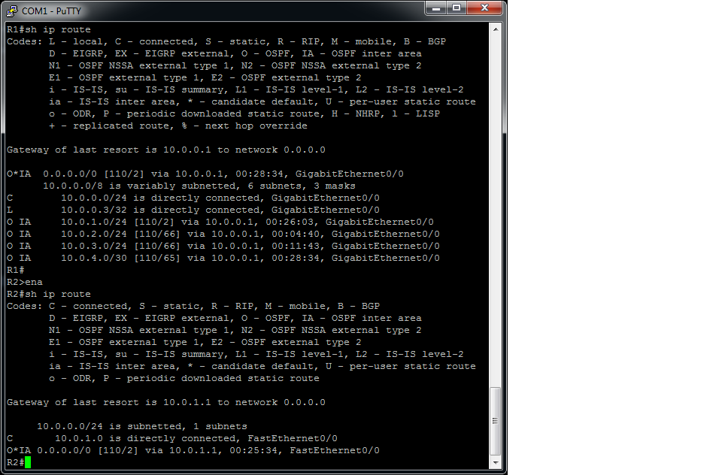

**R3 and R4**

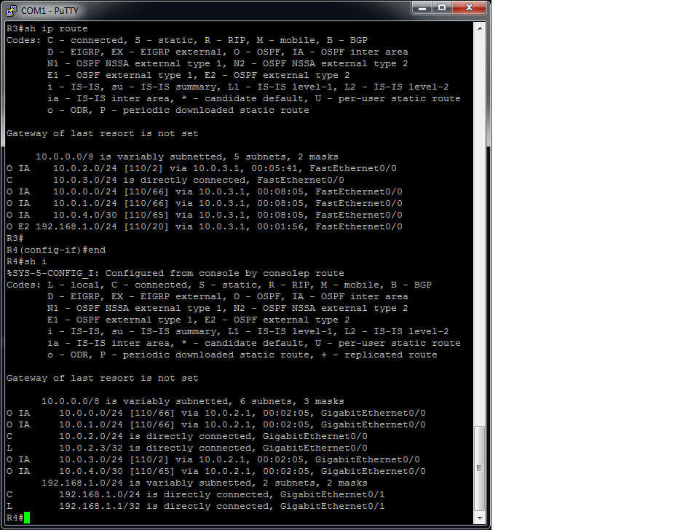

**R5 and R6**

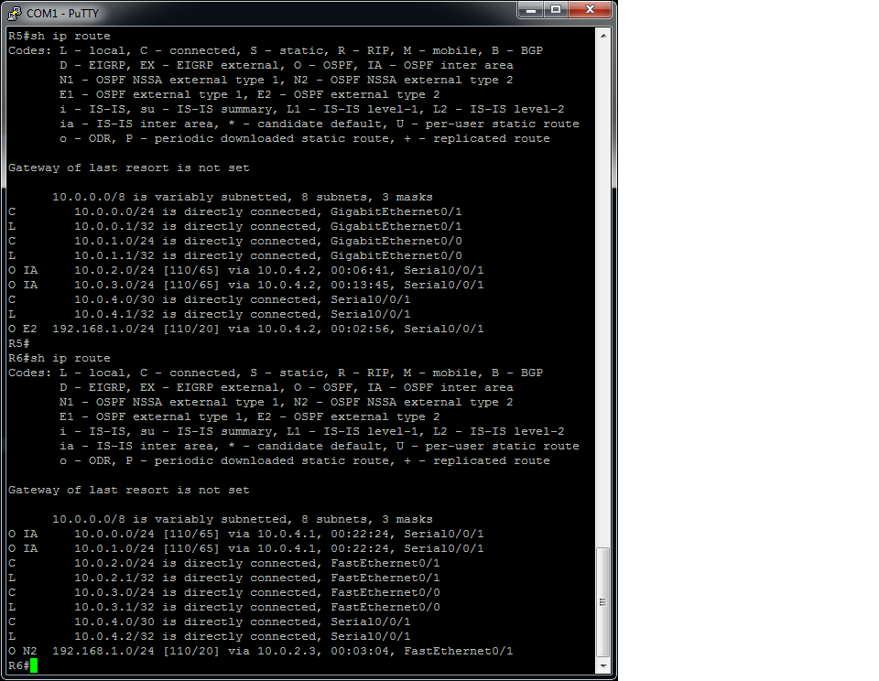

**R7**

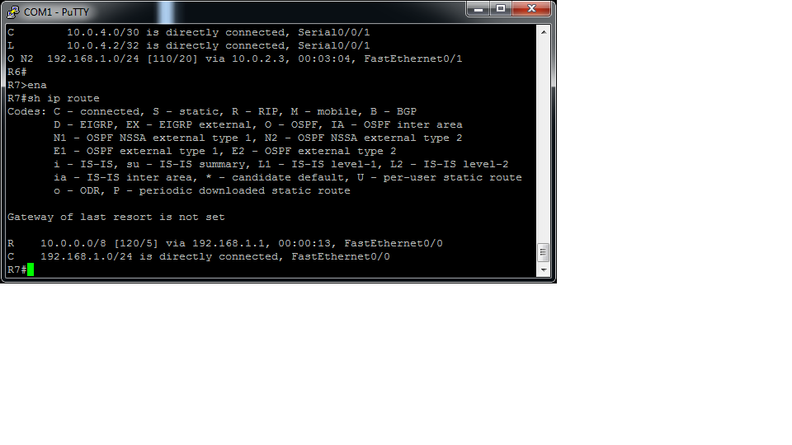

**Wireshark Captures**

**Regular networks**

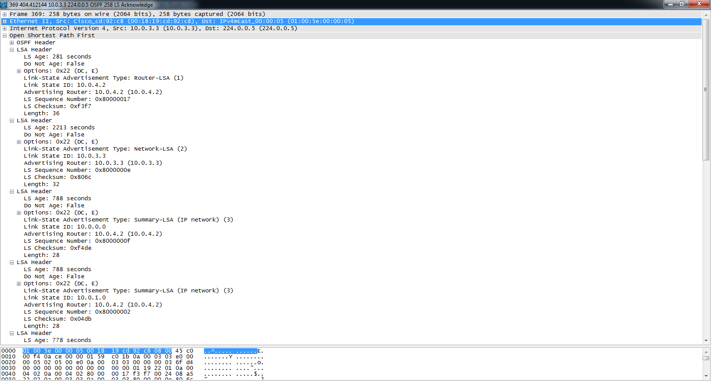

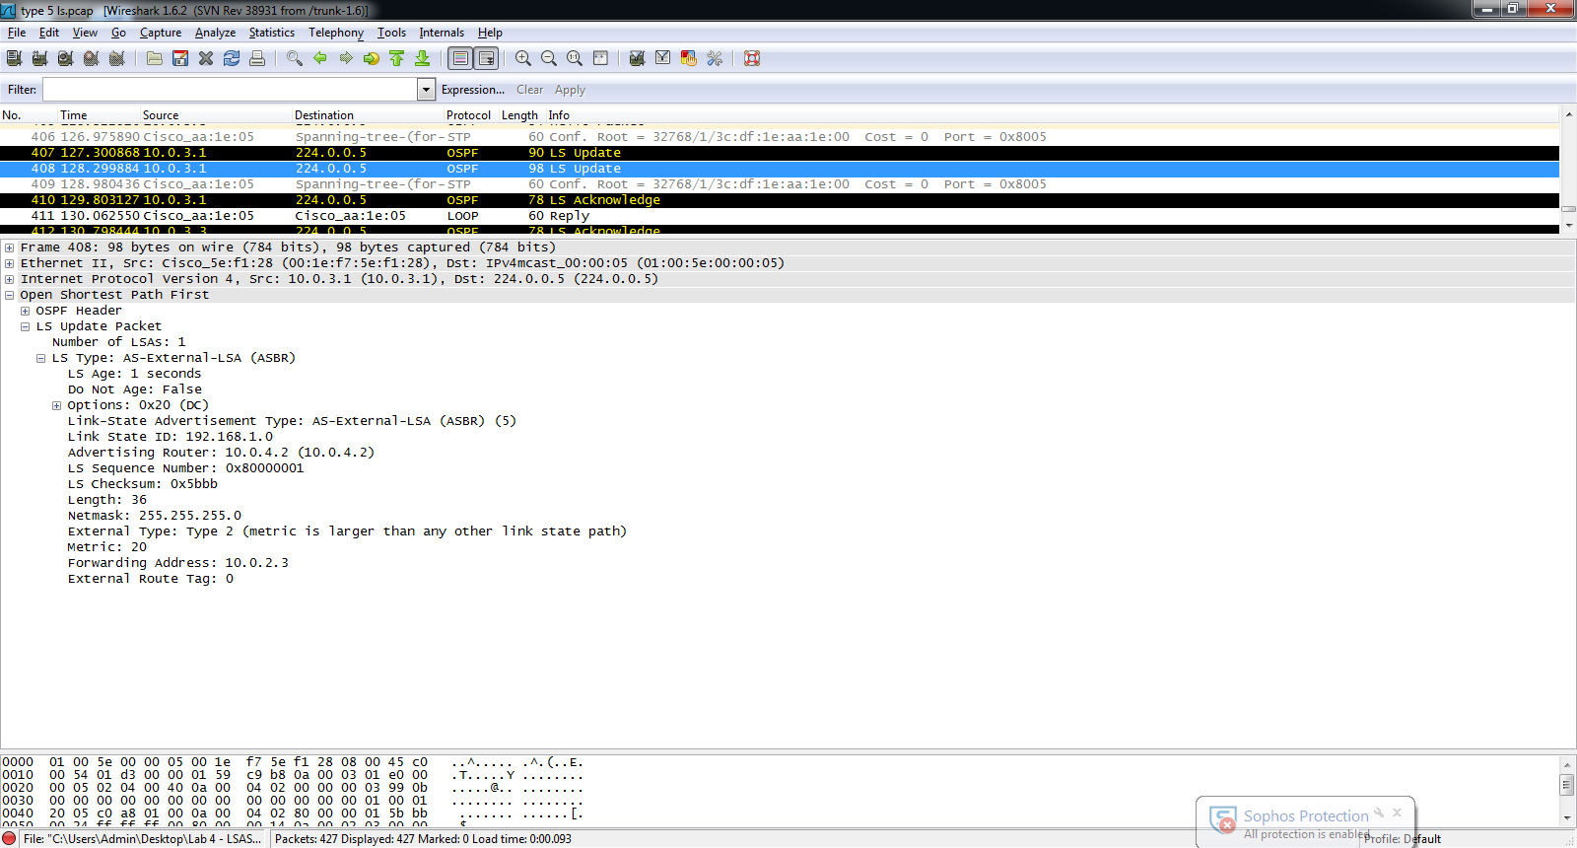

**Stubby networks**

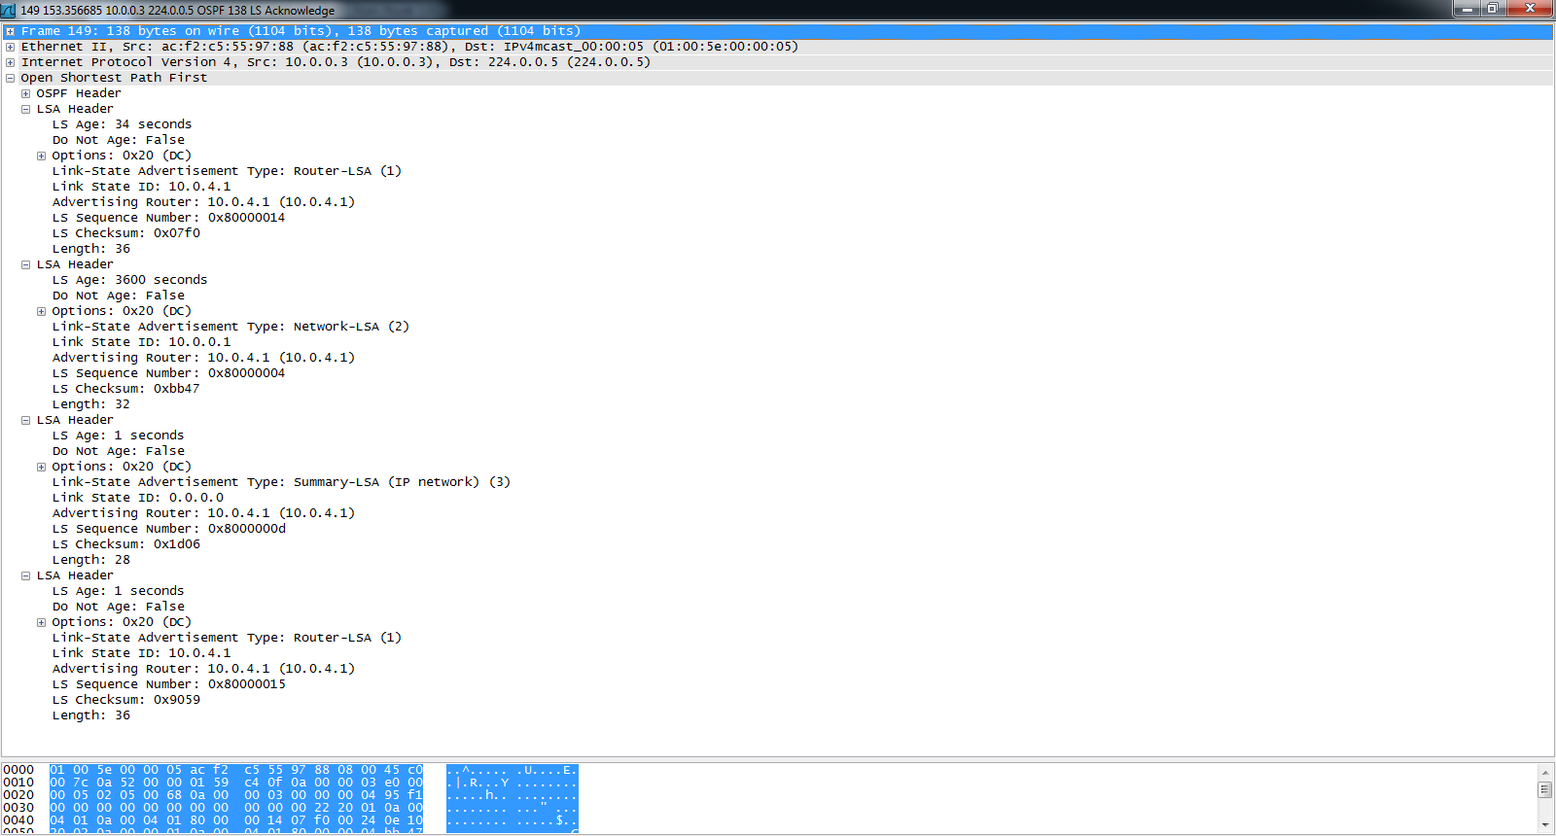

**Totally Stubby networks**

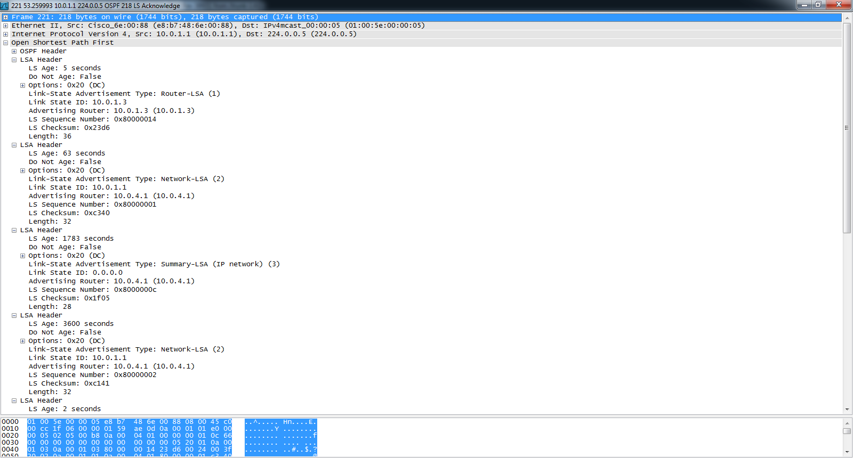

**Not-so-stubby networks**

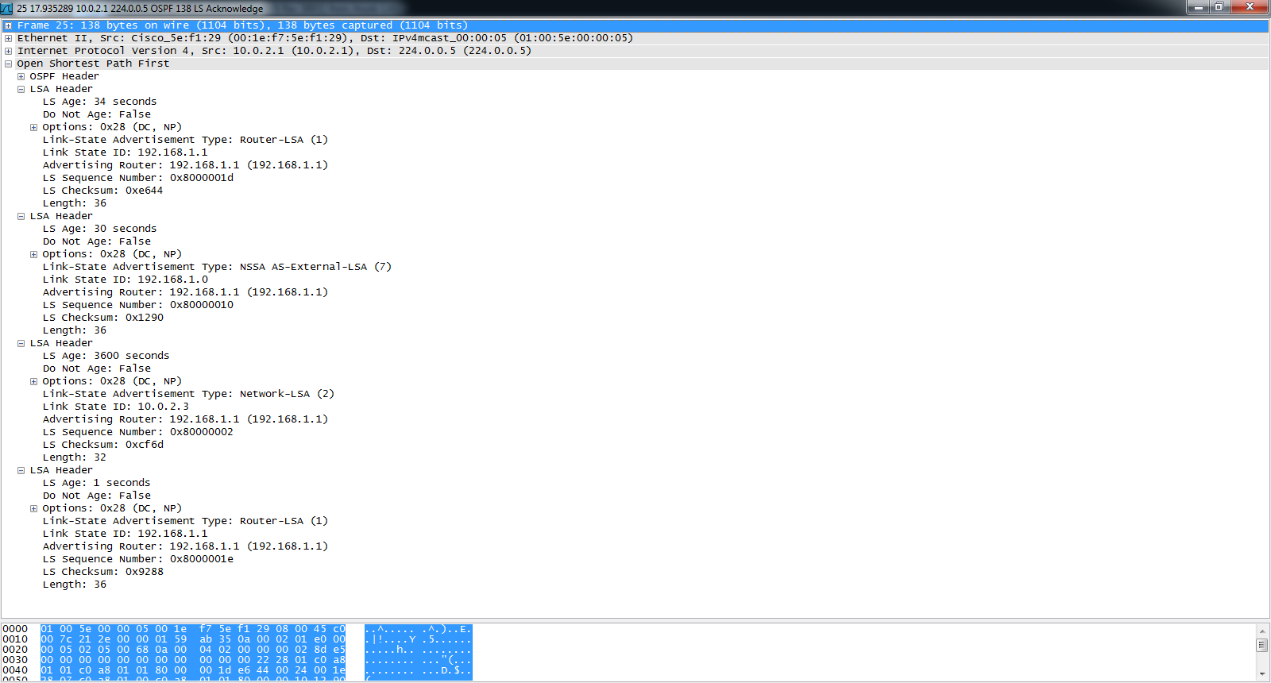

The screenshot below shows that NSSA is supported in the OSPF header.

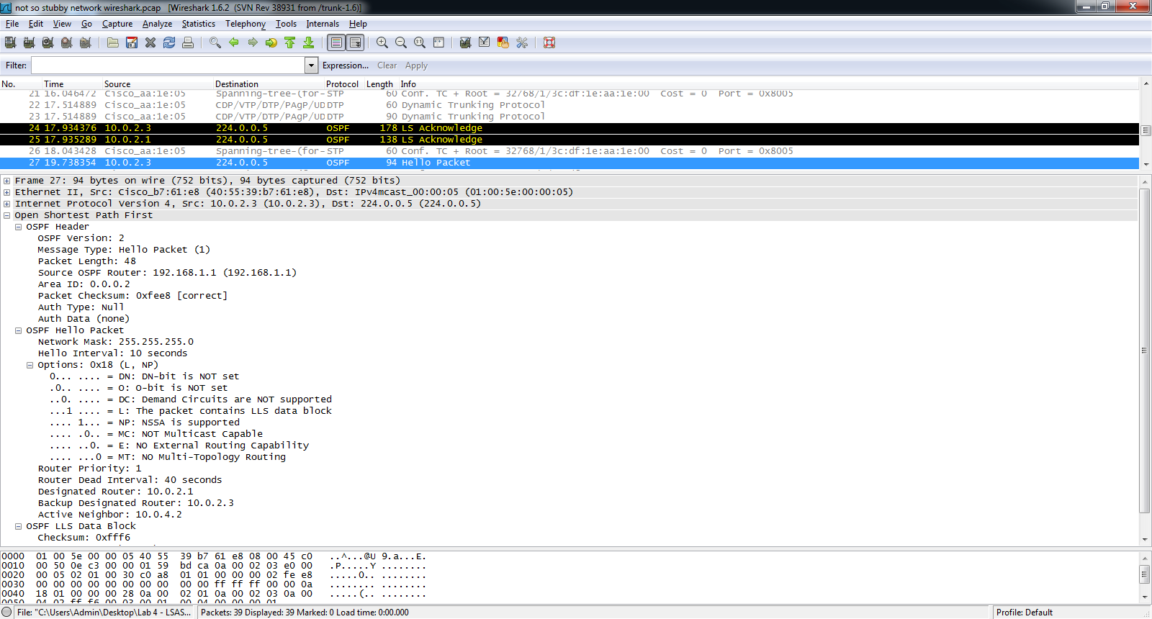

**Problems**

Researching which areas had which LSAs was particularly difficult. Although I established full connectivity throughout the network, I did not get the LSAs that I wanted initially. Type 3 LSAs were entirely missing in the regular area, the Stubby area, and the Totally Stubby area, despite the presence of all routes in the routing table. I spent more time than I had expected on searching for the right interfaces to use the *shutdown* and *no shutdown* commands in order to receive the right LSAs.  
 In addition, I had difficulty getting all the routes that were needed. After copy-pasting my commands, I realized that interfaces were shutdown, and therefore, routes were not present in the routing table. I spent a great amount of time trying to comprehend why the network did not have full connectivity unlike the network that had full connectivity the day before. Redistribution also played a role in the absence of some of my routes; RIP and OSPF did not redistribute their respective routes easily since I often did not ensure that all the routes in their respective networks were present. In other words, some commands required for running both routing protocols, like *Router (config-router)# version 2* and *Router (config-router)# no auto-summary* were not issued. Redistribution also took a while to be present in the routing tables so after hastily judging that my commands were incorrect, I had to troubleshoot the topology quite a few times.   
**Conclusion**

Despite the numerous difficulties that I had to undergo, the overall result of this lab was satisfactory. I was able to establish full connectivity between devices in the network, and to identify which types of LSAs were present in each stub network, using Wireshark. I also learned the different commands that helped me configure a certain area into a Stubby, Totally Stubby, or a Not-so-stubby area, a skill that will be essential to a network engineer when having to configure Stub networks.